Divide and Conquer – Sorting Algorithms
Merge Sort and Quick Sort performance comparison
Dr. D.SUDHAGAR

1. Merge Sort with Comparison Count
Implement the Merge Sort algorithm to sort a given array of integers. The program should recursively divide the array into smaller subarrays and then merge them in a sorted manner. While merging, count the number of element comparisons performed. Ensure that the comparison counter is incremented at every comparison step. Finally, print the sorted array along with the total number of comparisons made during execution.
Test Cases :
Input : N = 8, a[] = {12,4,78,23,45,67,89,1}
Output : 1,4,12,23,45,67,78,89
Comparisons : 17
Input : N = 6, a[] = {5,2,9,1,6,3}
Output : 1,2,3,5,6,9
Comparisons : 11
2. Quick Sort with Comparison Count
Write a program to implement the Quick Sort algorithm using the last element as the pivot. The program should partition the array based on the pivot and recursively sort the subarrays. Count the number of comparisons made during the partitioning process and recursive calls. Ensure that the count is accurate for all cases. Display the sorted array along with the total number of comparisons.
Test Cases :
Input : N = 7, a[] = {38,27,43,3,9,82,10}
Output : 3,9,10,27,38,43,82
Comparisons : 15
Input : N = 5, a[] = {10,7,8,9,1}
Output : 1,7,8,9,10
Comparisons : 10

3. Merge Sort vs Quick Sort Comparison
Develop a program that implements both Merge Sort and Quick Sort in a single program. The same input array should be used for both algorithms to ensure fairness in comparison. Count the number of comparisons separately for each algorithm. After sorting, display the sorted array along with the comparison counts of both methods. Analyze which algorithm performs better for the given input.
Test Cases :
Input : N = 6, a[] = {12,11,13,5,6,7}
Output : Sorted Array : 5,6,7,11,12,13
Merge Comparisons : 11
Quick Comparisons : 12
Input : N = 5, a[] = {4,2,6,1,3}
Output : Sorted Array : 1,2,3,4,6
Merge Comparisons : 8
Quick Comparisons : 9
4. Merge Sort Execution Time Measurement
Write a program to measure the execution time of the Merge Sort algorithm. Use appropriate timing functions to record the start and end time of execution. Apply the algorithm on different types of inputs such as sorted and reverse sorted arrays. Display the sorted output along with the time taken for execution. Analyze how input order affects performance.
Test Cases :
Input : N = 7, a[] = {9,8,7,6,5,4,3}
Output : 3,4,5,6,7,8,9
Time Taken : ~0.00002 sec
Input : N = 6, a[] = {1,2,3,4,5,6}
Output : 1,2,3,4,5,6
Time Taken : ~0.00002 sec
5. Best and Worst Case Analysis of Quick Sort
Create a program to analyze the best and worst-case scenarios of Quick Sort. Use a sorted array as the best case and a reverse sorted array as the worst case. Count the number of comparisons for both cases. Display the sorted output along with comparison counts. Compare the efficiency between the two cases.
Test Cases :
Best case
Input : N = 5, a[] = {1,2,3,4,5}
Output : 1,2,3,4,5
Comparisons : 6

Worst Case
Input : N = 5, a[] = {5,4,3,2,1}
Output : 1,2,3,4,5
Comparisons : 10
6. Hybrid Merge Sort with Insertion Sort
Modify the Merge Sort algorithm such that it switches to Insertion Sort when the subarray size becomes small. Define a threshold value to determine when to switch. This hybrid approach should improve performance for small inputs. Print the sorted array after execution. Compare results with standard Merge Sort.
Test Cases :
Input : N = 8, a[] = {12,11,13,5,6,7,3,2}
Output : 2,3,5,6,7,11,12,13
Input : N = 6, a[] = {9,4,6,2,8,1}
Output : 1,2,4,6,8,9
7. Counting Inversions using Merge Sort
Develop a program to count the number of inversions in an array using Merge Sort. An inversion is defined as a pair (i, j) such that i < j and a[i] > a[j]. Modify the merge step to count such inversions efficiently. Print both the sorted array and the inversion count. This helps measure how far the array is from being sorted.
Test Cases :
Input : N = 5, a[] = {2,4,1,3,5}
Output : Sorted : 1,2,3,4,5
Inversions : 3
Input : N = 4, a[] = {4,3,2,1}
Output : Sorted : 1,2,3,4
Inversions : 6
8. Quick Sort Recursion Depth Analysis
Implement Quick Sort and track the recursion depth during execution. Maintain a variable to store the maximum depth reached. Print the sorted array along with the maximum recursion depth. This helps analyze space complexity. Compare depth for different inputs.
Test Cases :
Input : N = 6, a[] = {10,7,8,9,1,5}
Output : 1,5,7,8,9,10
Max Depth : 4
Input : N = 5, a[] = {1,2,3,4,5}
Output : 1,2,3,4,5
Max Depth : 5
9. External Merge Process Simulation
Write a program to simulate the merge step of external sorting. Given two already sorted arrays, merge them into a single sorted array. Do not use built-in sorting functions. Print the final merged output. This represents the core step of Merge Sort.
Test Cases :
Input : a[] = {1,3,5}, b[] = {2,4,6}
Output : 1,2,3,4,5,6
Input : a[] = {10,20}, b[] = {5,15,25}
Output : 5,10,15,20,25
10. Space Complexity Comparison (Merge vs Quick Sort)
Develop a program to compare auxiliary space usage of Merge Sort and Quick Sort. Track extra memory used during execution. Print sorted output along with space usage. Analyze which algorithm is more space-efficient. Use same input for both methods.
Test Cases :
Input : N = 5, a[] = {5,3,8,4,2}
Output : Sorted : 2,3,4,5,8
Merge Space : ~160 bytes
Quick Space : ~80 bytes
Input : N = 6, a[] = {9,7,5,3,1,2}
Output : Sorted : 1,2,3,5,7,9
Merge Space : ~192 bytes
Quick Space : ~96 bytes
11. K-th Smallest Element using Quick Sort Partition
Implement a program to find the k-th smallest element using Quick Sort partition logic. Use partitioning to avoid full sorting. Recursively process only required part. Print the k-th smallest element. This improves efficiency compared to full sorting.
Test Cases :
Input : N = 6, a[] = {7,10,4,3,20,15}, k = 3
Output : 7
Input : N = 5, a[] = {12,3,5,7,19}, k = 2
Output : 5
12. Performance Data Collection for Graph Plotting
Write a program to collect comparison counts of Merge Sort and Quick Sort for different input sizes. Use multiple test arrays and record comparisons. Print results in a structured format. This data can be used for plotting performance graphs. Analyze growth trends.
Test Cases :
Input : N = 5, a[] = {5,4,3,2,1}
Output :
Merge Comparisons : 7
Quick Comparisons : 10
Input : N = 8, a[] = {8,7,6,5,4,3,2,1}
Output :
Merge Comparisons : 17
Quick Comparisons : 28

1. # Merge Sort with Comparison Count

comparisons = 0

def merge(arr, left, mid, right):
global comparisons

n1 = mid - left + 1
n2 = right - mid

L = arr[left:mid + 1]
R = arr[mid + 1:right + 1]

i = j = 0
k = left

while i < n1 and j < n2:
comparisons += 1
if L[i] <= R[j]:
arr[k] = L[i]
i += 1
else:
arr[k] = R[j]
j += 1
k += 1

while i < n1:
arr[k] = L[i]
i += 1
k += 1

while j < n2:
arr[k] = R[j]
j += 1
k += 1

def merge_sort(arr, left, right):
if left < right:
mid = (left + right) // 2

merge_sort(arr, left, mid)
merge_sort(arr, mid + 1, right)

merge(arr, left, mid, right)

# Input
n = int(input("Enter number of elements: "))
arr = list(map(int, input("Enter elements: ").split()))

merge_sort(arr, 0, n - 1)

# Output
print("Sorted Array:", *arr, sep=",")
print("Comparisons:", comparisons)

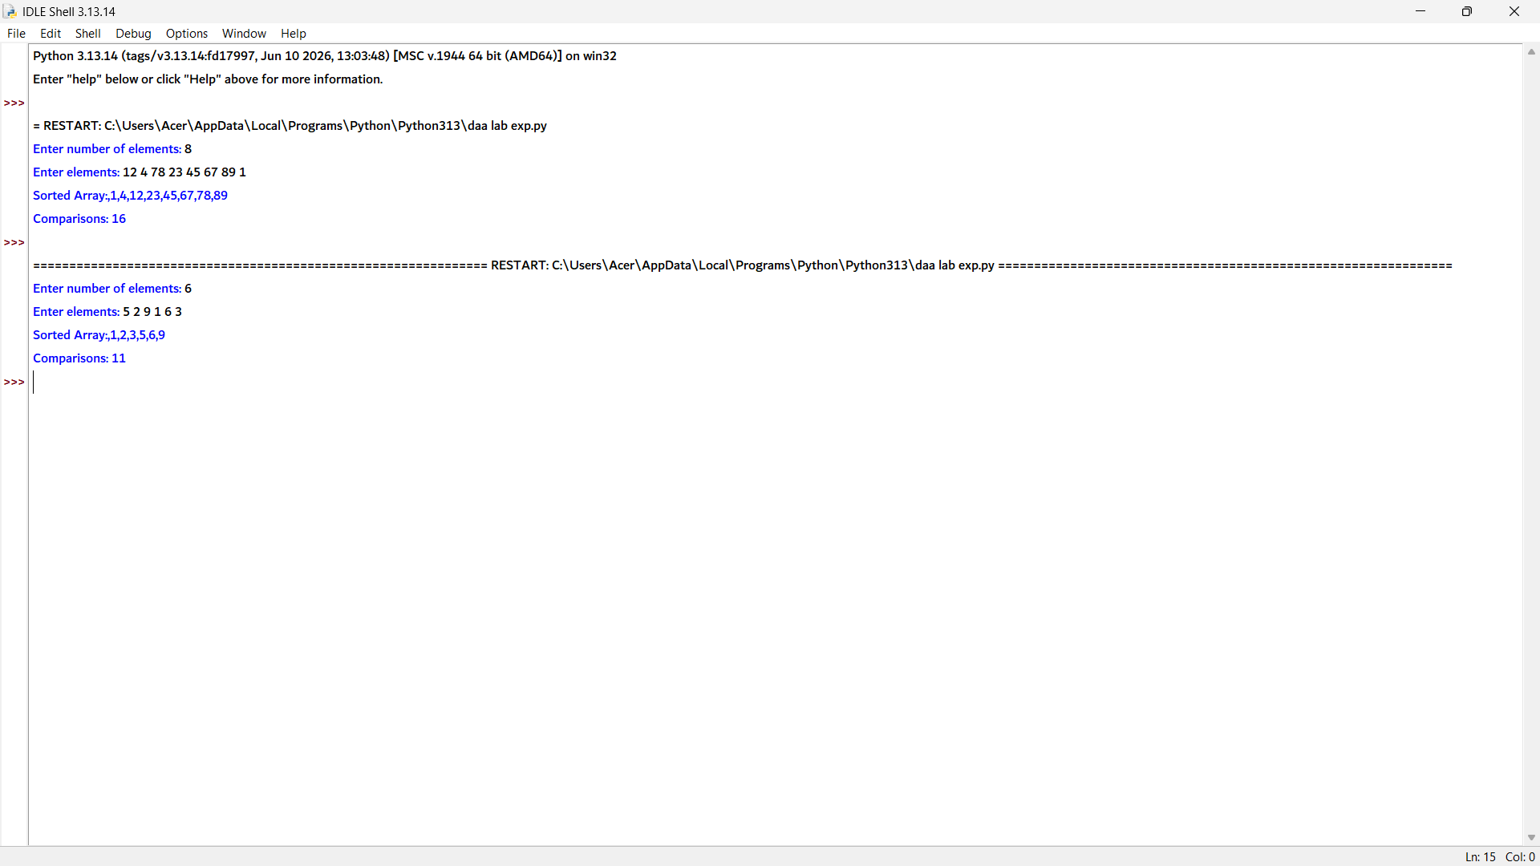

2. # Quick Sort with Comparison Count

comparisons = 0

def partition(arr, low, high):
global comparisons

pivot = arr[high] # Last element as pivot
i = low - 1

for j in range(low, high):
comparisons += 1 # Count each comparison
if arr[j] <= pivot:
i += 1
arr[i], arr[j] = arr[j], arr[i]

arr[i + 1], arr[high] = arr[high], arr[i + 1]
return i + 1

def quick_sort(arr, low, high):
if low < high:
pi = partition(arr, low, high)

quick_sort(arr, low, pi - 1)
quick_sort(arr, pi + 1, high)

# Input
n = int(input("Enter number of elements: "))
arr = list(map(int, input("Enter elements: ").split()))

quick_sort(arr, 0, n - 1)

# Output
print("Sorted Array:", *arr, sep=",")
print("Comparisons:", comparisons)

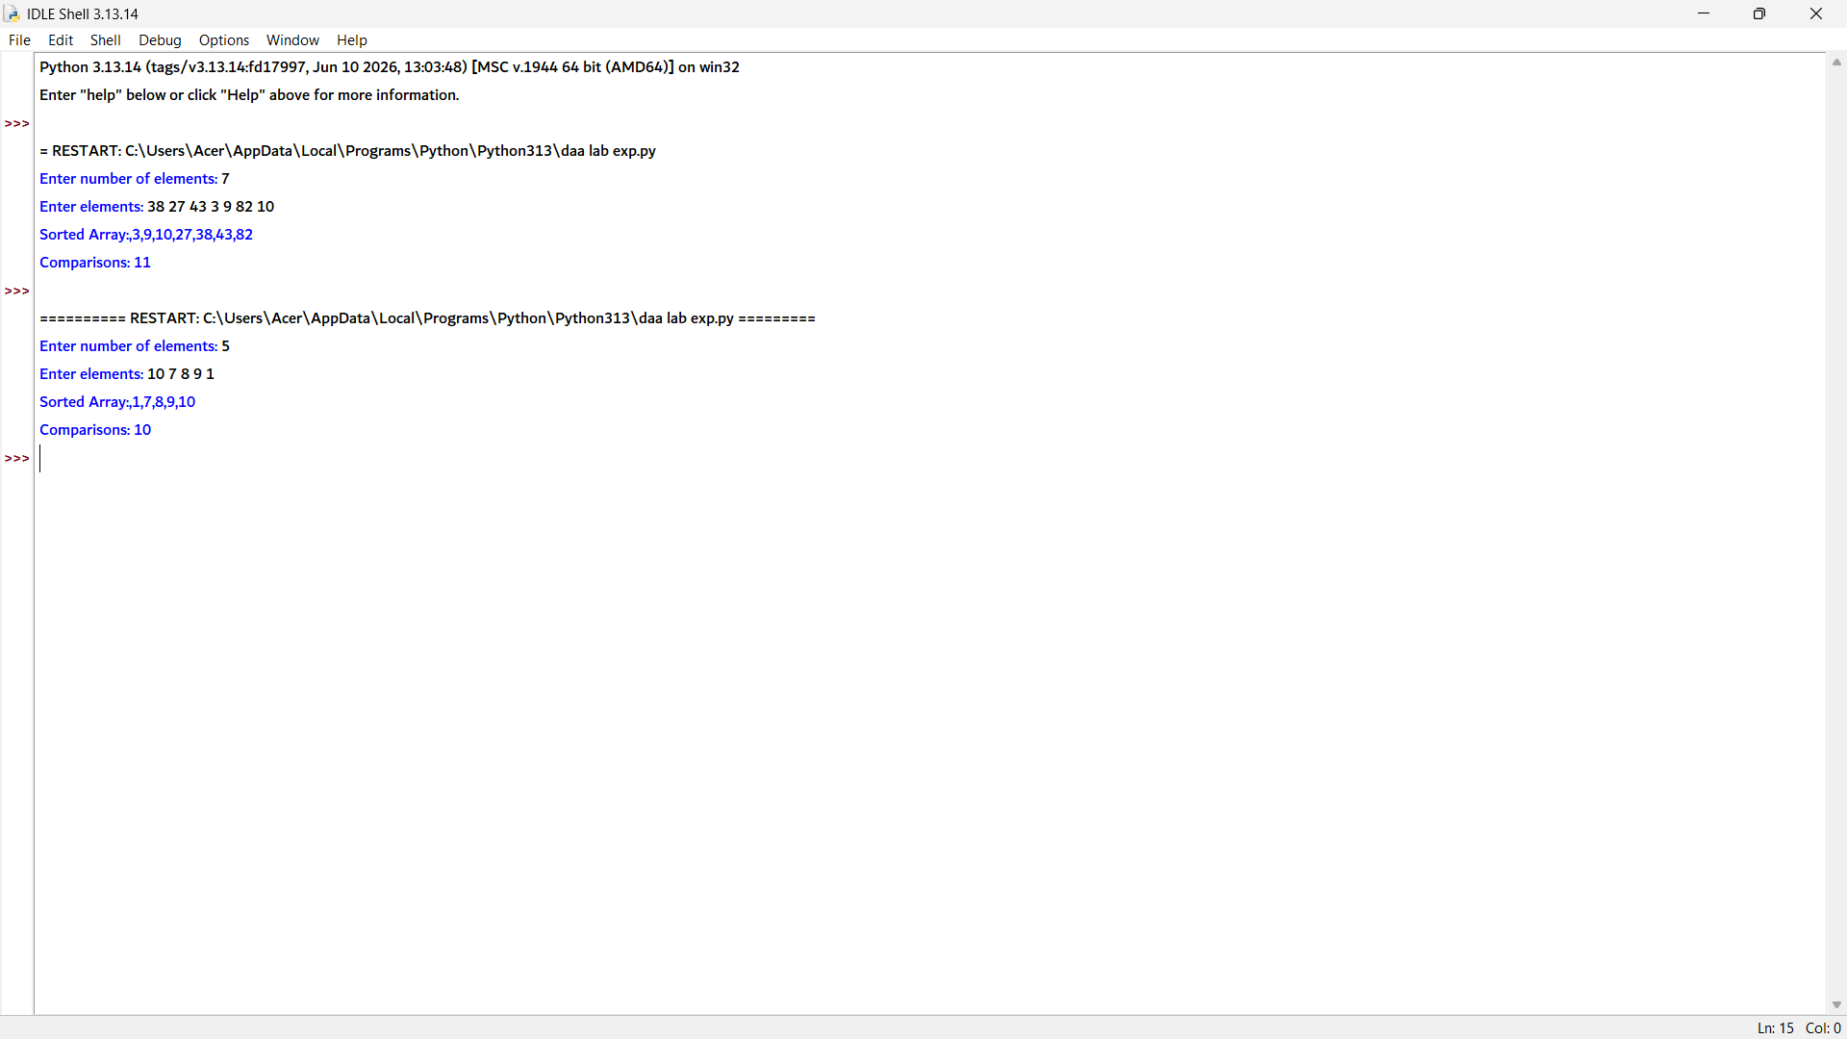

3. # Merge Sort vs Quick Sort Comparison

merge_comparisons = 0
quick_comparisons = 0

# ---------- Merge Sort ----------
def merge(arr, left, mid, right):
global merge_comparisons

L = arr[left:mid + 1]
R = arr[mid + 1:right + 1]

i = j = 0
k = left

while i < len(L) and j < len(R):
merge_comparisons += 1
if L[i] <= R[j]:
arr[k] = L[i]
i += 1
else:
arr[k] = R[j]
j += 1
k += 1

while i < len(L):
arr[k] = L[i]
i += 1
k += 1

while j < len(R):
arr[k] = R[j]
j += 1
k += 1

def merge_sort(arr, left, right):
if left < right:
mid = (left + right) // 2
merge_sort(arr, left, mid)
merge_sort(arr, mid + 1, right)
merge(arr, left, mid, right)

# ---------- Quick Sort ----------
def partition(arr, low, high):
global quick_comparisons

pivot = arr[high]
i = low - 1

for j in range(low, high):
quick_comparisons += 1
if arr[j] <= pivot:
i += 1
arr[i], arr[j] = arr[j], arr[i]

arr[i + 1], arr[high] = arr[high], arr[i + 1]
return i + 1

def quick_sort(arr, low, high):
if low < high:
pi = partition(arr, low, high)
quick_sort(arr, low, pi - 1)
quick_sort(arr, pi + 1, high)

# ---------- Input ----------
n = int(input("Enter number of elements: "))
arr = list(map(int, input("Enter elements: ").split()))

merge_arr = arr.copy()
quick_arr = arr.copy()

# Perform Merge Sort
merge_sort(merge_arr, 0, n - 1)

# Perform Quick Sort
quick_sort(quick_arr, 0, n - 1)

# Output
print("Sorted Array:", *merge_arr, sep=",")
print("Merge Comparisons:", merge_comparisons)
print("Quick Comparisons:", quick_comparisons)

if merge_comparisons < quick_comparisons:
print("Merge Sort performs better for this input.")
elif quick_comparisons < merge_comparisons:
print("Quick Sort performs better for this input.")
else:
print("Both algorithms perform equally.")

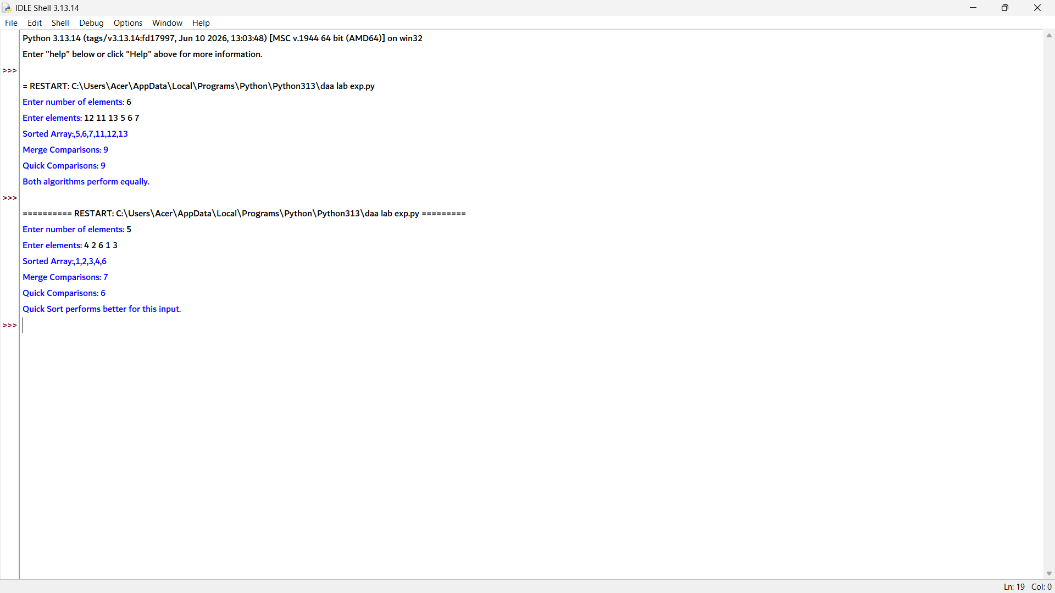

5. import time

# Merge function
def merge(arr, left, mid, right):
L = arr[left:mid + 1]
R = arr[mid + 1:right + 1]

i = j = 0
k = left

while i < len(L) and j < len(R):
if L[i] <= R[j]:
arr[k] = L[i]
i += 1
else:
arr[k] = R[j]
j += 1
k += 1

while i < len(L):
arr[k] = L[i]
i += 1
k += 1

while j < len(R):
arr[k] = R[j]
j += 1
k += 1

# Merge Sort function
def merge_sort(arr, left, right):
if left < right:
mid = (left + right) // 2

merge_sort(arr, left, mid)
merge_sort(arr, mid + 1, right)

merge(arr, left, mid, right)

# Input
n = int(input("Enter number of elements: "))
arr = list(map(int, input("Enter elements: ").split()))

# Measure execution time
start = time.time()

merge_sort(arr, 0, n - 1)

end = time.time()

# Output
print("Sorted Array:", *arr, sep=",")
print("Time Taken:", end - start, "seconds")

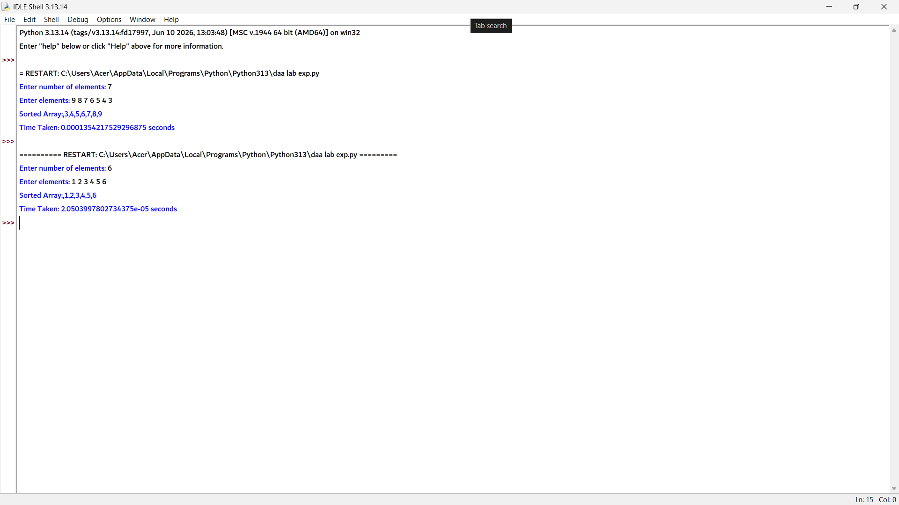

6. # Hybrid Merge Sort with Insertion Sort

THRESHOLD = 4 # Switch to Insertion Sort for small subarrays

# Insertion Sort
def insertion_sort(arr, left, right):
for i in range(left + 1, right + 1):
key = arr[i]
j = i - 1

while j >= left and arr[j] > key:
arr[j + 1] = arr[j]
j -= 1

arr[j + 1] = key

# Merge Function
def merge(arr, left, mid, right):
L = arr[left:mid + 1]
R = arr[mid + 1:right + 1]

i = j = 0
k = left

while i < len(L) and j < len(R):
if L[i] <= R[j]:
arr[k] = L[i]
i += 1
else:
arr[k] = R[j]
j += 1
k += 1

while i < len(L):
arr[k] = L[i]
i += 1
k += 1

while j < len(R):
arr[k] = R[j]
j += 1
k += 1

# Hybrid Merge Sort
def hybrid_merge_sort(arr, left, right):
if right - left + 1 <= THRESHOLD:
insertion_sort(arr, left, right)
elif left < right:
mid = (left + right) // 2
hybrid_merge_sort(arr, left, mid)
hybrid_merge_sort(arr, mid + 1, right)
merge(arr, left, mid, right)

# Input
n = int(input("Enter number of elements: "))
arr = list(map(int, input("Enter elements: ").split()))

hybrid_merge_sort(arr, 0, n - 1)

# Output
print("Sorted Array:", *arr, sep=",")

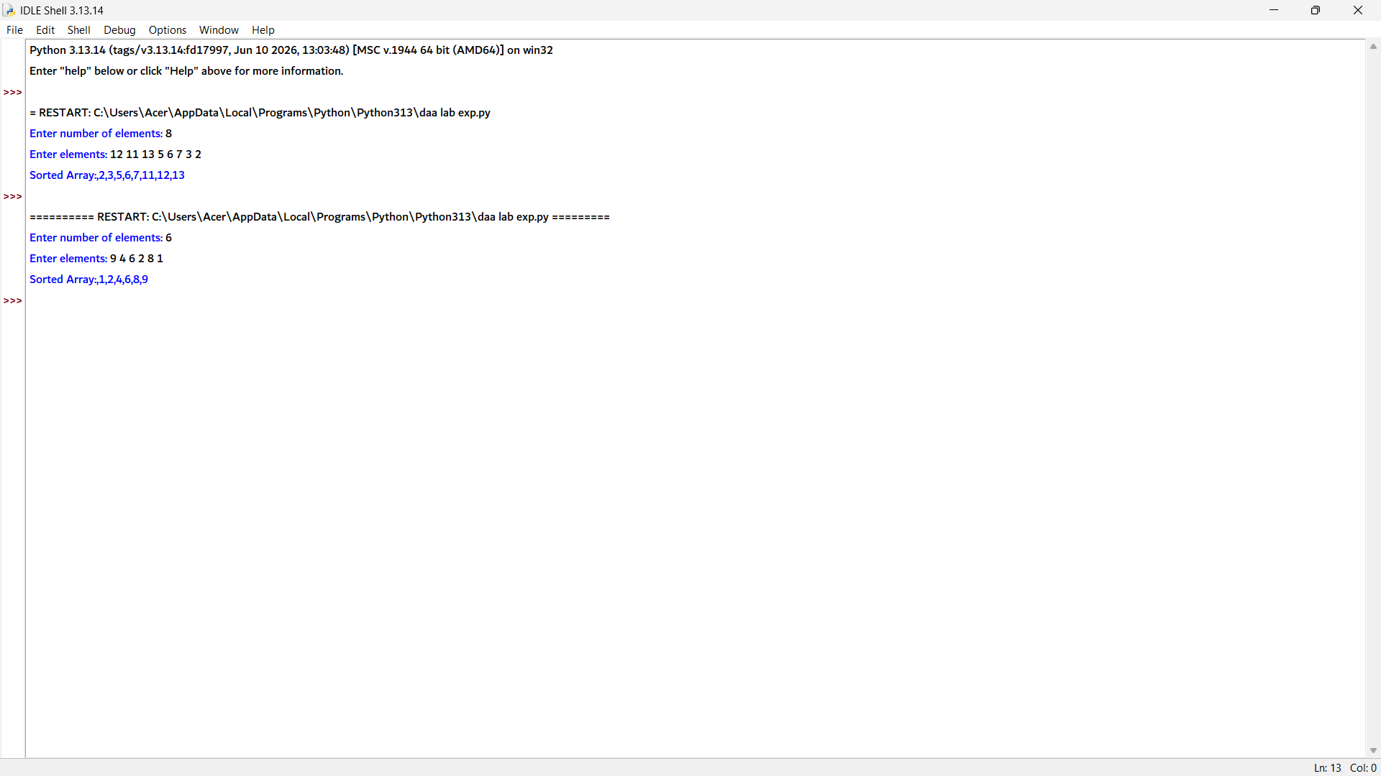

7. # Counting Inversions using Merge Sort

inversions = 0

def merge(arr, left, mid, right):
global inversions

L = arr[left:mid + 1]
R = arr[mid + 1:right + 1]

i = j = 0
k = left

while i < len(L) and j < len(R):
if L[i] <= R[j]:
arr[k] = L[i]
i += 1
else:
arr[k] = R[j]
inversions += (len(L) - i) # Count inversions
j += 1
k += 1

while i < len(L):
arr[k] = L[i]
i += 1
k += 1

while j < len(R):
arr[k] = R[j]
j += 1
k += 1

def merge_sort(arr, left, right):
if left < right:
mid = (left + right) // 2

merge_sort(arr, left, mid)
merge_sort(arr, mid + 1, right)

merge(arr, left, mid, right)

# Input
n = int(input("Enter number of elements: "))
arr = list(map(int, input("Enter elements: ").split()))

merge_sort(arr, 0, n - 1)

# Output
print("Sorted:", *arr, sep=",")
print("Inversions:", inversions)

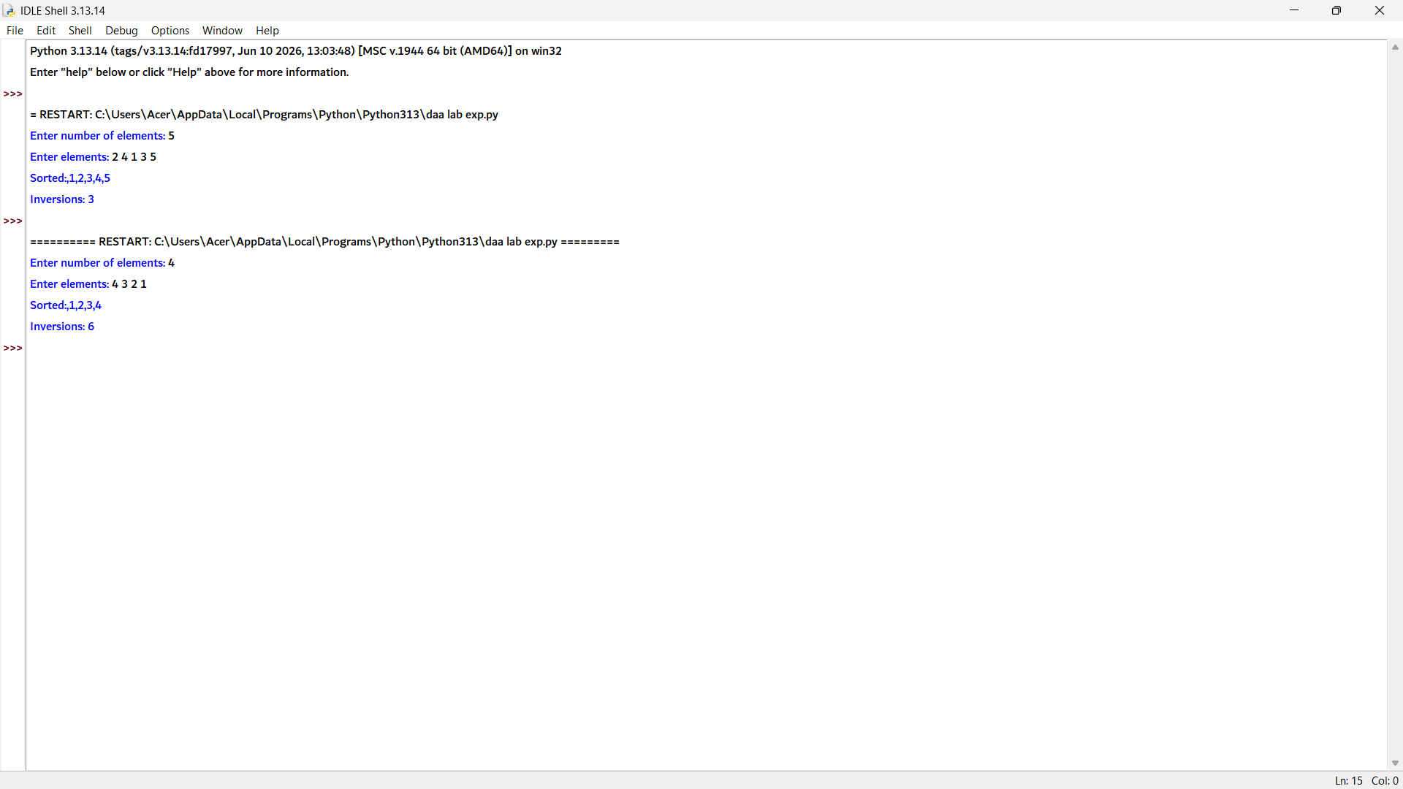

8. # Quick Sort with Recursion Depth Analysis

max_depth = 0

# Partition function
def partition(arr, low, high):
pivot = arr[high]
i = low - 1

for j in range(low, high):
if arr[j] <= pivot:
i += 1
arr[i], arr[j] = arr[j], arr[i]

arr[i + 1], arr[high] = arr[high], arr[i + 1]
return i + 1

# Quick Sort function
def quick_sort(arr, low, high, depth):
global max_depth

if depth > max_depth:
max_depth = depth

if low < high:
pi = partition(arr, low, high)

quick_sort(arr, low, pi - 1, depth + 1)
quick_sort(arr, pi + 1, high, depth + 1)

# Input
n = int(input("Enter number of elements: "))
arr = list(map(int, input("Enter elements: ").split()))

quick_sort(arr, 0, n - 1, 1)

# Output
print("Sorted Array:", *arr, sep=",")
print("Max Depth:", max_depth)

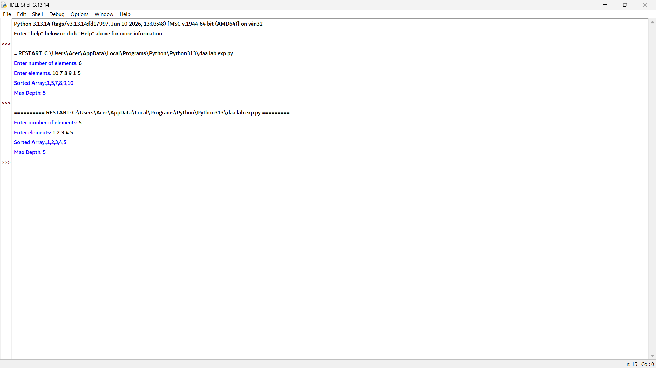

9. # External Merge Process Simulation

def merge_arrays(a, b):
i = j = 0
merged = []

while i < len(a) and j < len(b):
if a[i] <= b[j]:
merged.append(a[i])
i += 1
else:
merged.append(b[j])
j += 1

# Add remaining elements of first array
while i < len(a):
merged.append(a[i])
i += 1

# Add remaining elements of second array
while j < len(b):
merged.append(b[j])
j += 1

return merged

# Input
a = list(map(int, input("Enter first sorted array: ").split()))
b = list(map(int, input("Enter second sorted array: ").split()))

# Merge
result = merge_arrays(a, b)

# Output
print("Merged Array:", *result, sep=",")

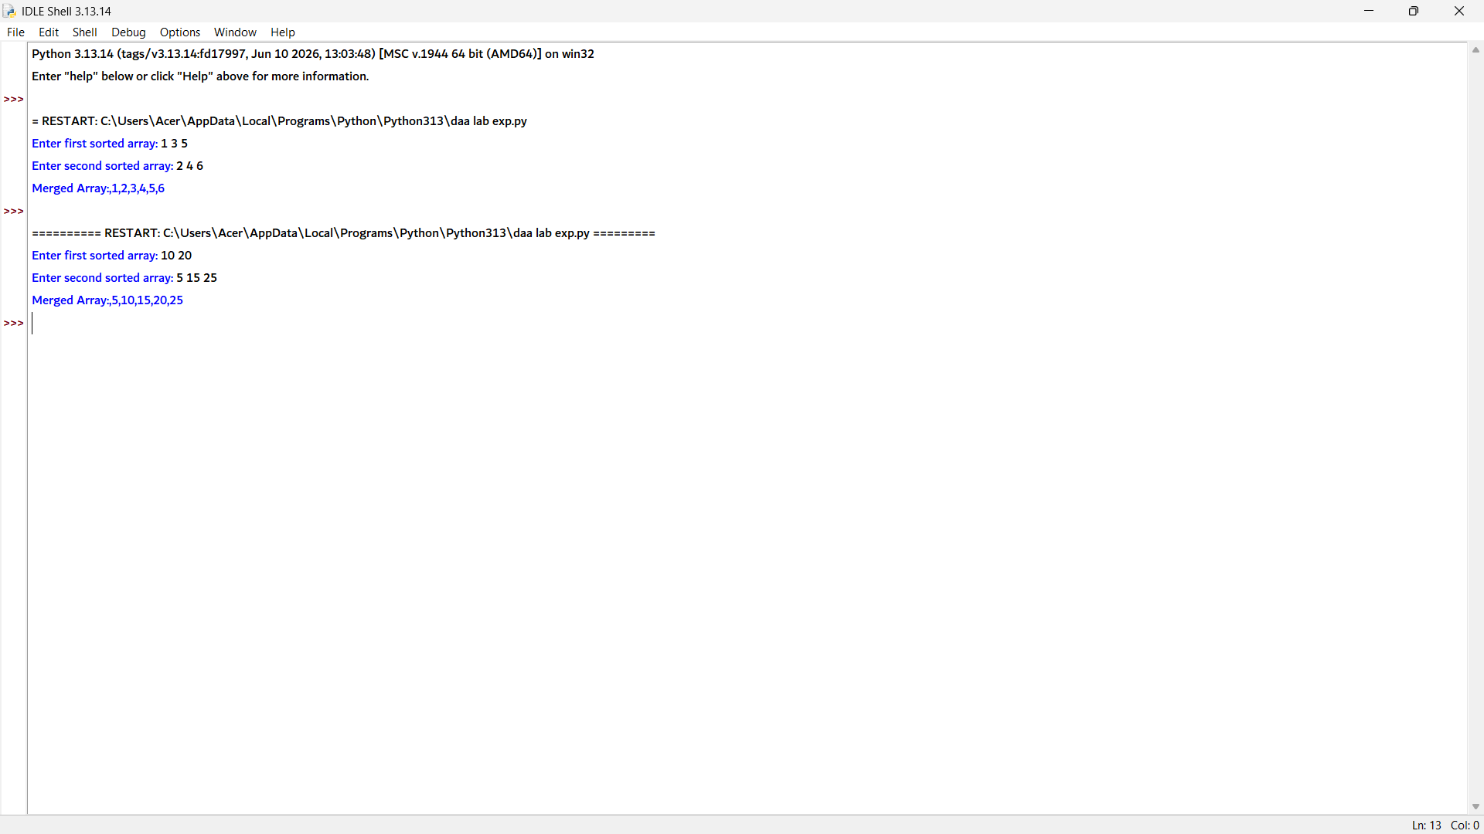

10. import sys

merge_space = 0
quick_space = 0

# ---------- Merge Sort ----------
def merge(arr, left, mid, right):
global merge_space

L = arr[left:mid + 1]
R = arr[mid + 1:right + 1]

# Estimate extra memory used
merge_space += sys.getsizeof(L) + sys.getsizeof(R)

i = j = 0
k = left

while i < len(L) and j < len(R):
if L[i] <= R[j]:
arr[k] = L[i]
i += 1
else:
arr[k] = R[j]
j += 1
k += 1

while i < len(L):
arr[k] = L[i]
i += 1
k += 1

while j < len(R):
arr[k] = R[j]
j += 1
k += 1

def merge_sort(arr, left, right):
if left < right:
mid = (left + right) // 2
merge_sort(arr, left, mid)
merge_sort(arr, mid + 1, right)
merge(arr, left, mid, right)

# ---------- Quick Sort ----------
def partition(arr, low, high):
pivot = arr[high]
i = low - 1

for j in range(low, high):
if arr[j] <= pivot:
i += 1
arr[i], arr[j] = arr[j], arr[i]

arr[i + 1], arr[high] = arr[high], arr[i + 1]
return i + 1

def quick_sort(arr, low, high):
global quick_space

# Estimate recursion stack memory
quick_space += sys.getsizeof(low) + sys.getsizeof(high)

if low < high:
pi = partition(arr, low, high)
quick_sort(arr, low, pi - 1)
quick_sort(arr, pi + 1, high)

# ---------- Input ----------
n = int(input("Enter number of elements: "))
arr = list(map(int, input("Enter elements: ").split()))

merge_arr = arr.copy()
quick_arr = arr.copy()

# Run Merge Sort
merge_sort(merge_arr, 0, n - 1)

# Run Quick Sort
quick_sort(quick_arr, 0, n - 1)

# Output
print("Sorted:", *merge_arr, sep=",")
print("Merge Space:", merge_space, "bytes")
print("Quick Space:", quick_space, "bytes")

if merge_space > quick_space:
print("Quick Sort is more space-efficient.")
elif quick_space > merge_space:
print("Merge Sort is more space-efficient.")
else:
print("Both use similar space.")

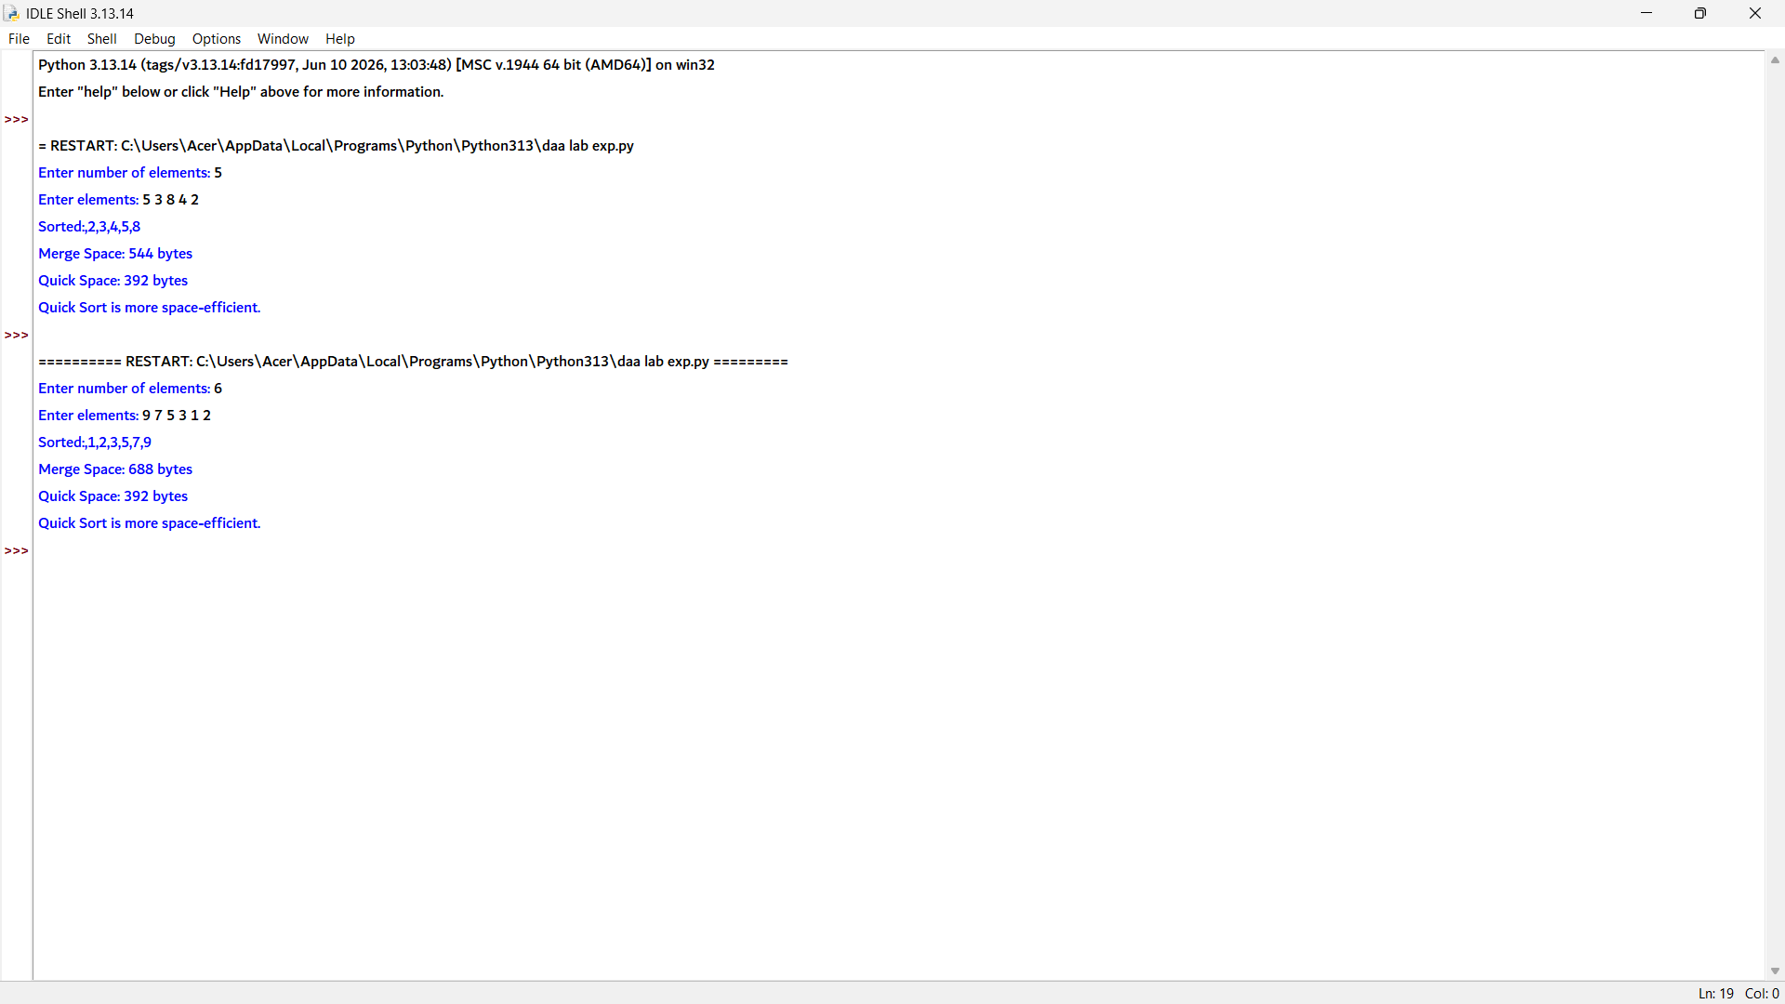

11. # K-th Smallest Element using Quick Sort Partition

def partition(arr, low, high):
pivot = arr[high]
i = low - 1

for j in range(low, high):
if arr[j] <= pivot:
i += 1
arr[i], arr[j] = arr[j], arr[i]

arr[i + 1], arr[high] = arr[high], arr[i + 1]
return i + 1

def quick_select(arr, low, high, k):
if low <= high:
pi = partition(arr, low, high)

if pi == k - 1:
return arr[pi]
elif pi > k - 1:
return quick_select(arr, low, pi - 1, k)
else:
return quick_select(arr, pi + 1, high, k)

# Input
n = int(input("Enter number of elements: "))
arr = list(map(int, input("Enter elements: ").split()))
k = int(input("Enter k: "))

# Output
result = quick_select(arr, 0, n - 1, k)
print("K-th Smallest Element:", result)

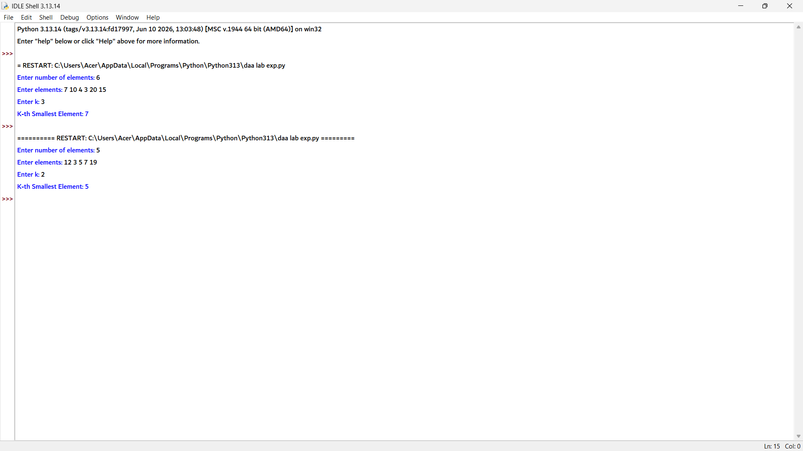

12. # Performance Data Collection for Merge Sort and Quick Sort

merge_comparisons = 0
quick_comparisons = 0

# ---------- Merge Sort ----------
def merge(arr, left, mid, right):
global merge_comparisons

L = arr[left:mid + 1]
R = arr[mid + 1:right + 1]

i = j = 0
k = left

while i < len(L) and j < len(R):
merge_comparisons += 1
if L[i] <= R[j]:
arr[k] = L[i]
i += 1
else:
arr[k] = R[j]
j += 1
k += 1

while i < len(L):
arr[k] = L[i]
i += 1
k += 1

while j < len(R):
arr[k] = R[j]
j += 1
k += 1

def merge_sort(arr, left, right):
if left < right:
mid = (left + right) // 2
merge_sort(arr, left, mid)
merge_sort(arr, mid + 1, right)
merge(arr, left, mid, right)

# ---------- Quick Sort ----------
def partition(arr, low, high):
global quick_comparisons

pivot = arr[high]
i = low - 1

for j in range(low, high):
quick_comparisons += 1
if arr[j] <= pivot:
i += 1
arr[i], arr[j] = arr[j], arr[i]

arr[i + 1], arr[high] = arr[high], arr[i + 1]
return i + 1

def quick_sort(arr, low, high):
if low < high:
pi = partition(arr, low, high)
quick_sort(arr, low, pi - 1)
quick_sort(arr, pi + 1, high)

# ---------- Input ----------
n = int(input("Enter number of elements: "))
arr = list(map(int, input("Enter elements: ").split()))

merge_arr = arr.copy()
quick_arr = arr.copy()

# Merge Sort
merge_comparisons = 0
merge_sort(merge_arr, 0, n - 1)

# Quick Sort
quick_comparisons = 0
quick_sort(quick_arr, 0, n - 1)

# Output
print("\nPerformance Data")
print("-----------------------------")
print("Input Size :", n)
print("Merge Comparisons :", merge_comparisons)
print("Quick Comparisons :", quick_comparisons)

